Assessment Task 1 Marking Guideline
Question 1
Planning (IPO)
Input | Process | Output
30% of Icass Mark  40% of Practical Assessment  30% of Examination | Read the students details and the 3 marks  - Multiply Icass mark by 0.3  - Multiply Practical Assignment mark by 0.4  - Mutliply internal exam by 0.3  Calculate Final mark by adding different marks together | Display  Student name  Final mark 50% or higher Leaner Passed.  Final mark below 50% Learner Failed.

Mark Allocation
Input 1 mark
Process
- Multiply marks
- Adding final mark
Outputs
Display of correct messages

#Program that calculates the students PLP marks for entry into Ncv courses  #declaring variables and getting values from the user  name= input("Enter name: ")  icass_mark = input("Enter the Icass Mark: ")  practical_test = input("Enter the Practical Test: ")  exam_mark = input("Enter the exam mark: ")  nameCleared = name.strip().title() #cleaning the text  #check that the correct values are entered  if name =="" or name.isdigit() or not icass_mark.isdigit() or not practical_test.isdigit() or not exam_mark.isdigit():  print("Enter valid name or marks: ")  else:  #converting strings to integers  icass_mark = int(icass_mark)  practical_test = int(practical_test)  exam_mark = int(exam_mark)  #Calculating the final Mark  finalmark = 0.3*icass_mark + 0.4*practical_test + 0.3*exam_mark  #Check for boundary values  if 0 <= icass_mark<=100 and 0<=practical_test<=100 and 0<= exam_mark<=100:  if finalmark >= 50:  print (f"Your final mark is : {finalmark:.0f} %")  print(nameCleared," ","You have qualified for NCV Level 2")  else:  print (f"Your final mark is : {finalmark:.0f}%") #Messa  print(nameCleared," ","Unfortunately, You have not qualified for NCV Level 2")  else:  print("Marks cannot be smaller than 0 or bigger than 100") #Error Message for boundary values | #header explaining what programme is about (1)  Prompts from use (1)  #declaring variables with meaniful names (1)  Cleaning text (1)  Check the correct input (2)  Conversions to write type (2)  Formula implemented correctly (2)  Recall variables in the formula (1)  Output Displays  Name of student with correct text case  Marks with unit and  Outcome message
(15)
Test Table:

Test Mark | Expected Result | Actual Result
Name: funeka sobopha  Icass mark: 50  Practical test: 50  Exam mark: 50 | Your final is : 50 %  Funeka Sobopha You have qualified for NCV Level 2 | 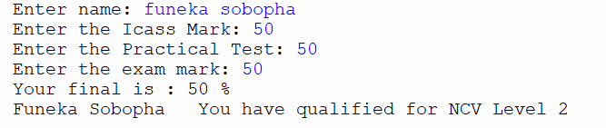
Name: sonto gama  Icass mark: 30  Practical test: 12  Exam mark: 50 | Your final is : 30%  Sonto Gama Unfortunately, You have not qualified for NCV Level 2 | 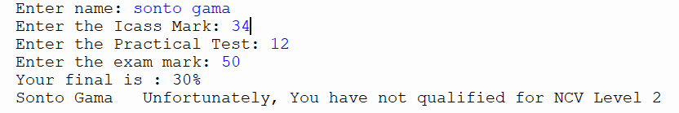

Question 2
Consider the following code:
mark = int (“20 percent”)
Will this statement execute successfully? Support your answer by explain how python interprets string values when converting to integers. (5)
Answer: No, A ValueError will occur because “72 percent “text is not a whole number, and it contains non-numeric characters and cannot be converted to an integer.
Mark Allocation
1 mark for No
1mark for stating an error will occur
1 mark for stating type of error
1 mark for stating its not a whole number or contains non numeric characters
1mark for stating it cannot be converted to integer

